Langley With Hardley Parish Council
Monthly Risk assessment Inspection LOG
PLAYGROUND, PLAY EQUIPMENT, BENCHES
Date of risk assessment: | Location/equipment: | Condition: | Work to be done: | Work done: | Inspection by:
13.4.25 | 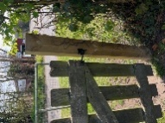Side gate | Secure. Latch working well. | None |  | JC
13.4.25 | 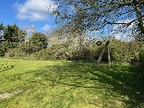zip wire | In good working condition | None |  | JC
13.4.25 | 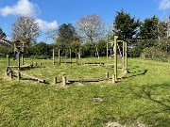Climbing/balancing circle | All fixings secure and safe | None |  | JC
13.4.25 | 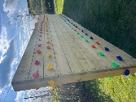Climbing wall | Secure and clean | None |  | JC
13.4.25 | 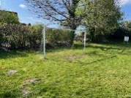Goal post | Posts and net secure | None |  | JC
13.4.25 | 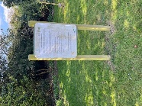Adult gym instructions | Instructions clear. Post secure | A bit of a clean | -Wiped on 13.4.25 JC | JC
13.4.25 | 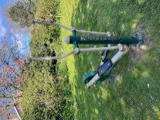Adult equipment 1 | In good working order | None |  | JC
13.4.25 | 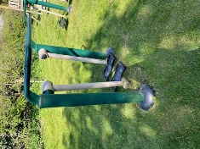Adult equipment 2 | In good working order | None |  | JC
13.4.25 | 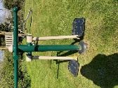Adult equipment 3 | In good working order | None |  | JC
13.4.25 | 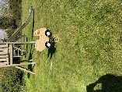Toddler spring seat | In good working order | None |  | JC
13.4.25 | 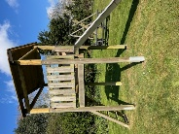Slide | Steps secure. Slide clean. In good order | None |  | JC
13.5.25 | 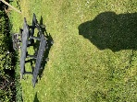Picnic bench | In safe condition. A bit of bird poo | A bit of a wipe | Wiped 13.4.25 JC | JC
13.4.25 | 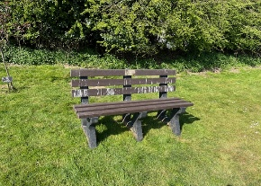Bench | In safe condition. Lots of bird poo | Needs a good clean |  | JC
13.4.25 | Waste Bin | Secure and not full | None |  | JC
13.4.25 | 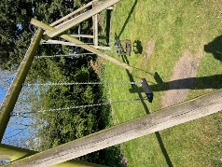Swings | Both secure and in good working order. | None |  | JC

