Langley With Hardley Parish Council
Monthly Risk assessment Inspection LOG
PLAYGROUND, PLAY EQUIPMENT, BENCHES
Date of risk assessment: | Location/equipment: | Condition: | Work to be done: | Work done: | Inspection by:
13.4.26 | 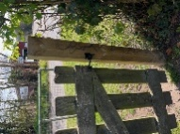Side gate | Secure.  New sign up | N/A |  | JC
13.4.26 | 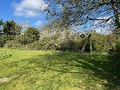zip wire | In good working condition. | None |  | JC
13.4.26 | 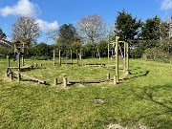Climbing/balancing circle | All fixings secure and safe  Some evidence of moss/lichen which may be slippy when wet. This is still applicable | None |  | JC
13.4.26 | 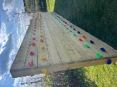Climbing wall | Secure and clean | None |  | JC
13.4.26 | 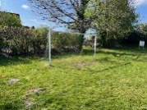Goal post | Grey corner struts need tightening and net needs re setting. | Tighten grey struts and re set net | Struts tightened on 24.3.26  Cable tie ends trimmed | JC
13.4.26 | 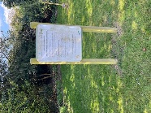Adult gym instructions | Instructions clear. Post secure | None |  | JC
13.4.26 | 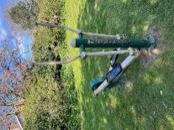Adult equipment 1 | In good working order | A bit of a clean needed on spring clean day |  | JC
13.4.26 | 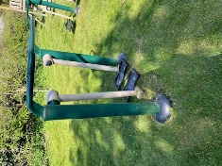Adult equipment 2 | In good working order | A bit of a spring clean needed on spring clean day |  | JC
13.4.26 | 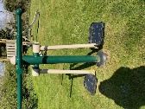Adult equipment 3 | In good working order | A bit of a clean needed on spring clean day |  | JC
13.4.26 | 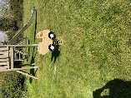Toddler spring seat | In good working order. | One of the covers on one of the bolts had broken and was sharp. | Trimmed sharp edge on 13.4.26 | JC
13.4.26 | 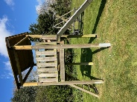Slide | All good | None |  | JC
13.4.26 | 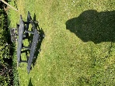Picnic bench | Clean | A bit of a clean needed on spring clean day |  | JC
13.4.26 | 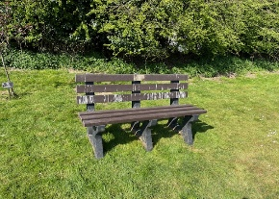Bench | Clean | A bit of a clean needed on spring clean day |  | JC
13.4.26 | Waste Bin | Secure and clean bin bag in place. | Bin had been recently emptied |  | JC
13.4.26 | 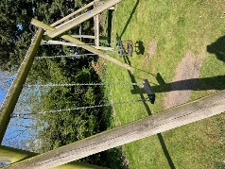Swings | Both secure and in good working order. | A bit of a clean needed on spring clean day |  | JC
13.4.26 | 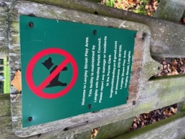 | This needs replacing with new contact information | New sign ordered- has this been received yet? |  | JC
13.4.26 | 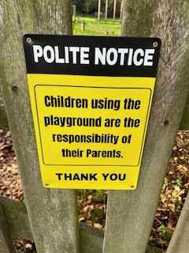 | New sign up on front gate  Maybe add another to main gate? | None |  | JC

