Langley With Hardley Parish Council
Monthly Risk assessment Inspection LOG
PLAYGROUND, PLAY EQUIPMENT, BENCHES
Date of risk assessment: | Location/equipment: | Condition: | Work to be done: | Work done: | Inspection by:
14.12.25 | 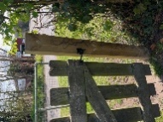Side gate | Secure.  New sign up | Take old one down |  | JC
14.12.25 | 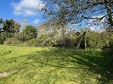zip wire | In good working condition. | None |  | JC
14.12.25 | 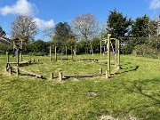Climbing/balancing circle | All fixings secure and safe  Some evidence of moss/lichen which may be slippy when wet. This is still applicable | None |  | JC
14.12.25 | 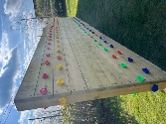Climbing wall | Secure and clean | None |  | JC
14.12.25 | 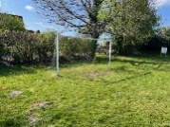Goal post | All safe and secure | None |  | JC
14.12.25 | 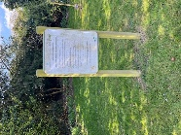Adult gym instructions | Instructions clear. Post secure | None |  | JC
14.12.25 | 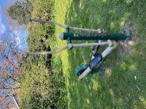Adult equipment 1 | In good working order | None |  | JC
14.12.25 | 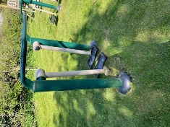Adult equipment 2 | In good working order | None |  | JC
14.12.25 | 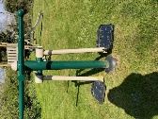Adult equipment 3 | In good working order | None |  | JC
14.12.25 | 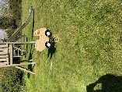Toddler spring seat | In good working order. | None |  | JC
14.12.25 | 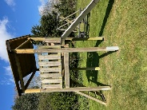Slide | All good | None |  | JC
14.12.25 | 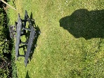Picnic bench | Clean | None |  | JC
14.12.25 | 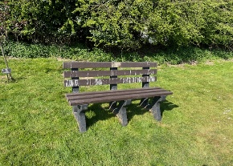Bench | Clean | None |  | JC
14.12.25 | Waste Bin | Secure and clean bin bag in place | None |  | JC
14.12.25 | 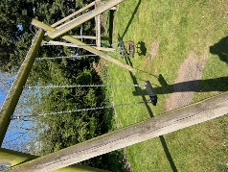Swings | Both secure and in good working order. | None |  | JC
14.12.25 | 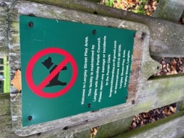 | This needs replacing with new contact information | Order a new sign |  | JC
14.12.25 | 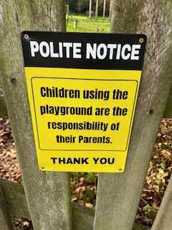 | New sign up on front gate | None |  | JC

