Langley With Hardley Parish Council
Monthly Risk assessment Inspection LOG
PLAYGROUND, PLAY EQUIPMENT, BENCHES
Date of risk assessment: | Location/equipment: | Condition: | Work to be done: | Work done: | Inspection by:
13.7.25 | 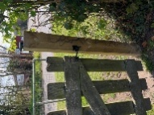Side gate | Sign is broken at bottom and shows old email | New sign showing correct email and contact number-discussed at last meeting |  | JC
13.7.25 | 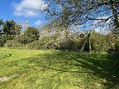zip wire | In good working condition | None | Booking specialist check in progress | JC
13.7.25 | 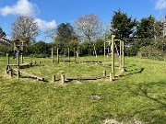Climbing/balancing circle | All fixings secure and safe | Be aware that the pieces of wood can loosen in warm weather as the wood shrinks and as pointed out in recent inspection may need replacing soon |  | JC
13.7.25 | 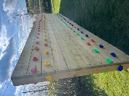Climbing wall | Secure and clean. | None |  | JC
13.7.25 | 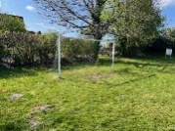Goal post | . All zip ties secure and in place and trimmed. Being used by two boys as I arrived who said it was “great to have such a good goalpost” | None |  | JC
13.7.25 | 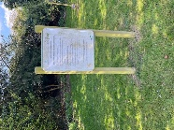Adult gym instructions | Instructions clean.Post secure | None |  | JC
13.7.25 | 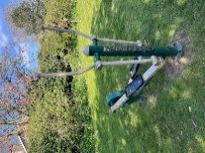Adult equipment 1 | In good working order | None |  | JC
13.7.25 | 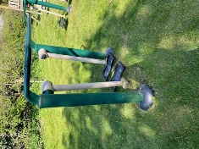Adult equipment 2 | In good working order | None |  | JC
13.7.25 | 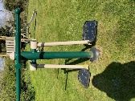Adult equipment 3 | In good working order | None |  | JC
13.7.25 | 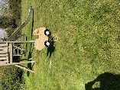Toddler spring seat | In good working order. Spring does show some rust but appears to be strong. | None |  | JC
13.7.25 | 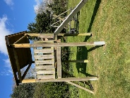Slide | Steps secure. Slide clean. In good order | None |  | JC
13.7.25 | 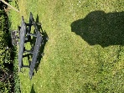Picnic bench | In safe condition. Virtually no bird poo! | None |  | JC
13.7.25 | 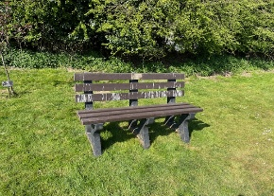Bench | In safe condition. Very little bird poo. | Monitor |  | JC
13.7.25 | Waste Bin | Secure and not full | None |  | JC
13.7.25 | 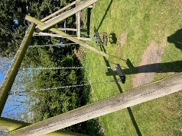Swings | Both secure and in good working order.  Being used by a child on my visit. |  |  | JC

