Langley With Hardley Parish Council
Monthly Risk assessment Inspection LOG
Date of risk assessment: | Location/equipment: | Condition: | Work to be done: | Work done: | Inspection by:
13.7.26 | 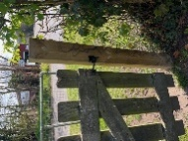Side gate | All good | N/A |  | JC
13.7.26 | 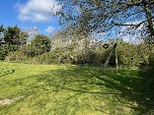zip wire | Still not received report? To discuss at July meeting. | Possibly tape up until report received as summer holidays coming up? | HG – zip wire repairs carried out 18th August by BBL Construction. They have advised very split wood.  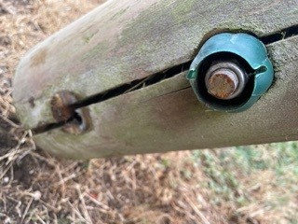 | JC
13.7.26 | 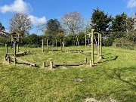Climbing/balancing circle | All fixings secure and safe | None |  | JC
13.7.26 | 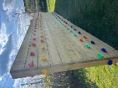Climbing wall | Secure and clean | None |  | JC
13.7.26 | 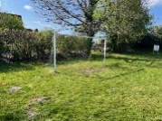Goal post | All good | None |  | JC
13.7.26 | 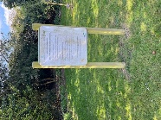Adult gym instructions | Instructions clear. Post secure | None |  | JC
13.7.26 | 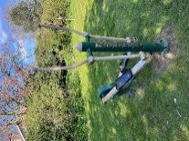Adult equipment 1 | In good working order | None |  | JC
13.7.26 | 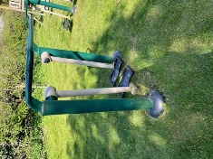Adult equipment 2 | In good working order | None |  | JC
13.7.26 | 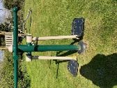Adult equipment 3 | In good working order | None |  | JC
13.7.26 | 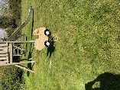Toddler spring seat | In good working order. | None |  | JC
13.7.26 | 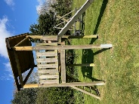Slide | All good | None |  | JC
13.7.26 | 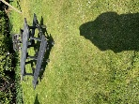Picnic bench | Bit of bird poo | None |  | JC
13.7.26 | 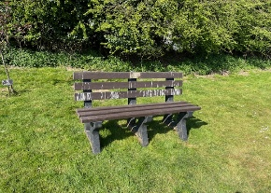Bench | Bit of bird poo | None |  | JC
13.7.26 | Waste Bin | Secure and being used | None |  | JC
13.7.26 | 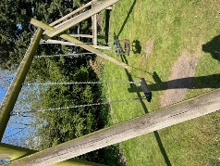Swings | Both secure and in good working order. | None |  | JC
13.7.26 | 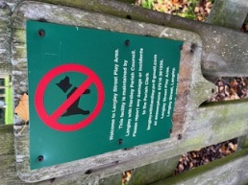 | This has now been replaced with new sign with new contact details | None |  | JC
13.7.26 | 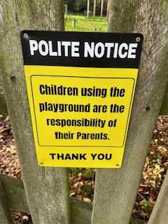 | New sign up on front gate | None |  | JC
PLAYGROUND, PLAY EQUIPMENT, BENCHES

