Langley With Hardley Parish Council
Monthly Risk assessment Inspection LOG
Date of risk assessment: | Location/equipment: | Condition: | Work to be done: | Work done: | Inspection by:
13.6.26 | 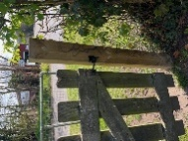Side gate | All good | N/A |  | JC
13.6.26 | 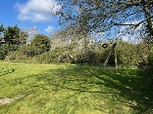zip wire | In view of resident concern myself and my husband checked the height of the seat. It was ok for me but too low for my husband. However this is supposed to be for children only? | See what RoSPA recommend after this month’s inspection. We may need a sign with weight/age limit? |  | JC
13.6.26 | 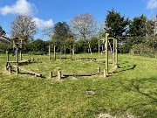Climbing/balancing circle | All fixings secure and safe | None |  | JC
13.6.26 | 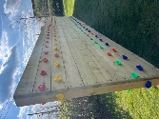Climbing wall | Secure and clean | None |  | JC
13.6.26 | 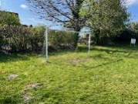Goal post | All good | None |  | JC
13.6.26 | 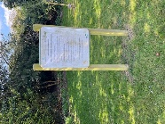Adult gym instructions | Instructions clear. Post secure | None |  | JC
13.6.26 | 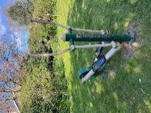Adult equipment 1 | In good working order | None |  | JC
13.6.26 | 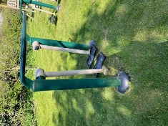Adult equipment 2 | In good working order | None |  | JC
13.6.26 | 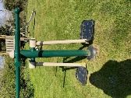Adult equipment 3 | In good working order | None |  | JC
13.6.26 | 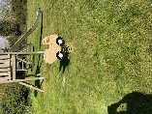Toddler spring seat | In good working order. | None |  | JC
13.6.26 | 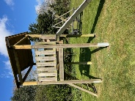Slide | All good | None |  | JC
13.6.26 | 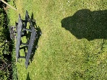Picnic bench | Bit of bird poo | None |  | JC
13.6.26 | 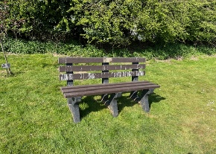Bench | Bit of bird poo | None |  | JC
13.6.26 | Waste Bin | Secure and clean bin bag in place. | None |  | JC
13.6.26 | 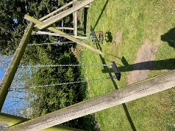Swings | Both secure and in good working order. | None |  | JC
13.6.26 | 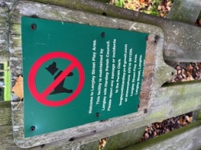 | This has now been replaced with new sign with new contact details | None |  | JC
13.6.26 | 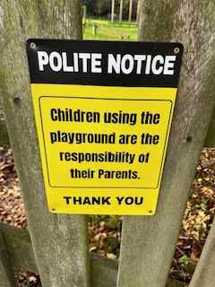 | New sign up on front gate | None |  | JC
PLAYGROUND, PLAY EQUIPMENT, BENCHES

