Langley With Hardley Parish Council
Monthly Risk assessment Inspection LOG
PLAYGROUND, PLAY EQUIPMENT, BENCHES
Date of risk assessment: | Location/equipment: | Condition: | Work to be done: | Work done: | Inspection by:
13.5.26 | 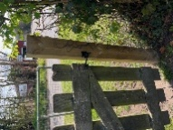Side gate | Secure. | None |  | JC
13.5.26 | 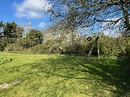zip wire | In good working condition. | None |  | JC
13.5.26 | 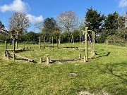Climbing/balancing circle | All fixings secure and safe | None |  | JC
13.5.26 | 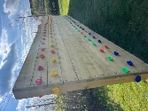Climbing wall | Secure and clean | None |  | JC
13.5.26 | 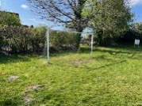Goal post | All secure | Re stretching and fixing of the net |  | JC
13.5.26 | 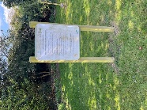Adult gym instructions | Instructions clear. Post secure | None |  | JC
13.5.26 | 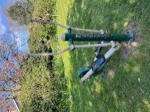Adult equipment 1 | In good working order | None |  | JC
13.5.26 | 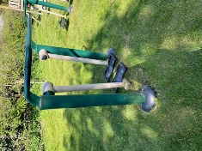Adult equipment 2 | In good working order | None |  | JC
13.5.26 | 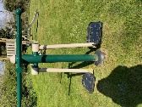Adult equipment 3 | In good working order | None |  | JC
13.5.26 | 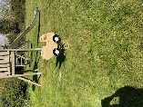Toddler spring seat | In good working order. | None |  | JC
13.5.26 | 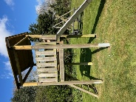Slide | All good | None |  | JC
13.5.26 | 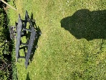Picnic bench | Clean | Keep an eye on the amount of bird poo | Was cleaned on spring clean day but birds have been | JC
13.5.26 | 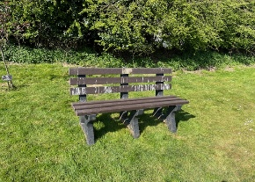Bench | Clean | Keep and eye on the amount of bird poo | Was cleaned on spring clean day but birds have been back | JC
13.5.26 | Waste Bin | Secure and clean bin bag in place. | None |  | JC
13.5.26 | 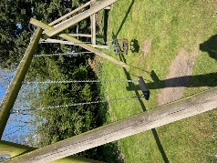Swings | Both secure and in good working order. | Keep an eye on baby swing for bird poo | Was cleaned on spring clean day but birds have been back | JC
13.5.26 | 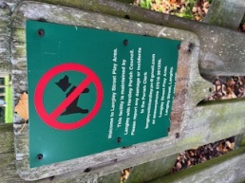 | New sign is up | None |  | JC
13.5.26 | 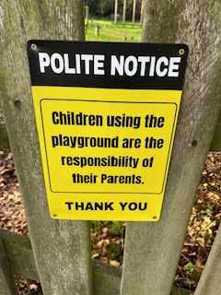 | All still secure | None |  | JC

